Test Project Module 3
(Packaging)

Submitted by: Group 3

Ahmed Al-Harassi (OM)
Chun-Liang Lin (TW)
Anne Grandt (NO)
Vivian de Oliveira Preto (BR)
Sarah Jones (AU), Patricia Dupuis (FR)
Lars Ake Flodmark (SE)

Member Country: OM, TW, NO, BR, AU, FR, SE

Contents
This Test Project proposal consists of the following documentation/files:
Este projeto esta baseado nos seguintes documentos
- 1. WSC2013_TP40_MODX_PRE_EN.doc
- 2. WSC2013_TP40_MODX_PRE (folder)

Introduction
The company, “Teas of the World” manufactures traditional and herbal teas from different regions of the world. It selects the best teas from the most prestigious plantations. The “Teas of the World” company has been slowly perfected over time. They believe that tea, like wine — requires meticulous care in it’s brewing process and is a ritual. The brewing process of tea is said to be associated with love and friendship.
A companhia “Teas of the World” fabrica tradicionalmente chás de diferentes regiões do mundo. seleciona os melhores chás das mais prestigiadas plantações. A companhia “Teas of the World” foi-se aperfeiçoando com o decorrer do tempo. Eles acreditam que chá, é como vinho, requer um meticuloso processo na hora de fazer o chá, como um ritual. O Processo de fazer o chá é associado com amor e amizade.

The “Teas of the World” brand is over 300 years old and has a strong history associated with its company name. The brand has created a dynasty where successors inherit the talent of their elders and follow in their footsteps. Aesthetics, elegance and the pursuit of perfection are the aims of “Teas of the World”.
A marca “Teas of the World” tem mais de 300 anos e tem uma histórias muito forte associada ao seu nome. A marca foi criada como uma dinastia onde os sucessores herdaram o talento de seus antecessores e seguiram seus passos. Estética, elegância e perfeição são os requisitos do “Teas of the World”.

“Teas of the World” are international leaders in the art of herbal teas. They offer products from all regions of the world, which links them to a culinary knowledge that enhances the taste while using their own basic principles and methodologies: “Teas of the World” embraces the art of brewing and enjoying tea and regards it as a "spiritual drink."
“ Teas of the World” é um dos lideres internacionais da arte dos chás de ervas. Eles oferecem produtos de todas as regiões do mundo, nas quais fazem ligação com a conhecimento culinário combinado com o gosto do chá enquanto utilizam seus próprios princípios e metodologias: “Teas of the World” abraça a ideia da arte do fazer o chá e do gostar do chá como uma bebida espiritual.

“Teas of the World” has established itself over the years as being renowned as a sensual, cultural and joyful brand. They have succeeded with this through their combinations of cultural references, aesthetics and flavour combinations. The brand constantly looks toward the future for new innovations and creative tea blends, which they do in their laboratories and out in the tea-fields
Teas of the World” estabeleceu por anos a imagem de ser reconhecida como sensual, cultural e alegre. Eles foram bem sucedidos nas suas combinações de referencias culturais, estéticas e combinações de sabores. A Marca procura constantemente inovações para o futuro e sabores/aromas criativos para os chás, eles fazem isto em seus laboratórios e nos campos de chá.

To develop the brands range, the company “Teas of the World” want to market a new line of "sensorial tea products". They are aiming this tea at tea drinkers between the ages of 20-50 years all over the world that appreciate a healthy lifestyle as these teas are guaranteed to be 100% organic.
Para desenvolver uma quantidade de sabores/aromas, a companhia “Teas of the World”, quer lançar no mercado uma nova linha a “sensorial tea products”. Eles querem atingir os consumidores de chá com idades compreendidas entre os 20-50 anos de todo o mundo e que apreciam um estilo de vida saudável já que estes chás são 100% orgânicos.

Description of project and tasks
You are required to create:
Deves criar:

1. A logo for the “Sensorial Tea” line of products
1. Um logo para a linha “Sensorial Tea”
2. An outer cardboard package that contains the three tea varieties inside
2- Uma embalagem em cartão que contém três variedades de chá dentro.
3. Three labels (stickers) — One for each of the tea varieties
3. Três etiquetas (autocolantes) – uma para cada variedade de chá

Task 1: Logo Creation
Tarefa 1: Criação do logo

You are required to create a logo for the tea range: “Sensorial Tea” (capital or lower-case according to your design). The name must be clear and readable. The proposed design should be adaptable to different blends of tea. You must use the text in Appendix 1.1
Deves criar um logo para a linha: “Sensorial Tea” (pode ser em caixa alta ou baixa de acordo com o teu design). O Nome deve estar legível e claro. O Design do logo deve adaptar-se aos diferentes aromas/sabores de chá. Deves utilizar o texto do Apendice 1.1

Technical Specifications:
Especificações técnicas:

• Trapping: 0.1 mm (if necessary)
Trapping: 0,1 mm (se necessário)
• Printing: Offset
Impressão: offset
• Native File format: EPS or AI
Arquivo original ou nativo: EPS ou AI
• File creation: Vector only
Arquivo apenas vectorial
• Colours:
Cores:
- One version in 2 x Pantone Uncoated Colours
- uma versão em 2 X Pantone Uncouted Colours
- One version in CMYK
Uma versão em CMYK

Electronic Files:
Arquivos electrónicos:

In a folder named Logo:
Numa pasta chamada Logo:

• One native version of the Pantone logo
Uma versão nativa do logo em PANTONE
• One PDF version of the Pantone logo
uma versão PDF do logo em PANTONE
• One native version of the CMYK logo
uma versão nativa do logo em CMYK
• One PDF version of the CMYK logo
uma versão PDF do logo em CMYK

Printed Files:
Impressão dos Arquivos
• The Pantone logo and the CMYK logo will be printed on an A4 sheet side-by-side
(each logo to be no larger than 14cm in it’s largest dimension)
o logo em PANTONE e o logo em CMYK serão impressos numa folha A4 lado a lado (cada logo deve ter no máximo 14 cm no lado maior)

Task 2: Cardboard Package
Tarefa2: Embalagem em cartão

The design of the package should convey an ecological and natural feel. You must use at least two or more of the images provided in Appendix 2.3. You may manipulate the images according to your design. You may create any other elements not supplied. You must create a working die-line for the package, which will be large enough to contain the three supplied clear plastic bags of tea. You must use all text in Appendix 2.1 and all files in Appendix 2.2. Your die-cut should be fully functional and practical and indicate all glue, cut and fold lines.
O design da embalagem deve ser ecológico e natural. Você deve usar no mínimo duas imagens do apêndice 2.3. Você pode manipular as imagens de acordo com o seu design. Você pode criar outros elementos que não foram fornecidos. Você deve criar uma faca para a embalagem que deve conter os três saquinhos de chá. Você deve utilizar todo o texto do apêndice 2.1 e todos os arquivos do apendice 2.2. A sua faca deve ser muito funcional e prática e deve indicar os pontos de cola, corte e dobra.

Technical specifications:
Especificações técnicas

• Stock: Uncoated card 230gsm in SRA3 size
Cartão: Uncoated card 230gsm in SRA3 size

• Bleed (if necessary): 3 mm
Sangra/bleed (se necessário): 3mm

• Colours: CMYK + Die-line plate
Cores: CMYK + Cortante

• Image resolution: 250 - 300dpi placed at 100%
• Image resolution: 250 - 300dpi placed at 100%

• ICC Profile for images:
Perfil de ICC para as imagens:
- CMYK: Uncoated FOGRA29 (ISO 12647-2:2004)

• Glue: You may use a maximum of 3 glue areas
Cola: você pode usar no máximo 3 pontos de cola

• Window: Optional according to your design
Janela: opcional de acordo com o seu design

• Ink Density: CMYK Maximum of 350%
Densidade da tinta: Maximo 350%

• PDF File Format: PDF/X-4:2008
Tipo de PDF: PDF/X-4:2008

• Native File format: INDD, EPS or AI
Arquivos originais/nativos: INDD, EPS ou AI

• Raster images: tiff, psd or eps for raster images. Note: you MUST NOT embed the raster files
Imagens raster: tiff, psd or eps for raster images. Você não deve imbutir/embeber as imagens raster

Packaging elements — All elements must be included in your package design:
Elementos da embalagem – todos os elementos abaixo devem estar incluídos:

• Logos to be included (These can be found in Appendix 2.2):
• Logos que deves incluir ( apendice 2.2)

- Teas of the world (to be used at least once in the design, but you may use it more than once)
- Teas of the World ( deve ser usado pelo menos 1 vez no seus design, mas vc pode usar mais de uma vez)

- Sensorial Tea (to be used at least once in the design, but you may use it more than once)
- Sensorial Tea ( deve ser usado pelo menos 1 vez no seus design, mas vc pode usar mais de uma vez)

- PEFC
- PEFC

- FSC
- FSC

- Recycle
- Reciclagem

• EAN 13 bar code in 100% black and 30mm wide
Codigo de barras em 100% preto e com 30 mm de largura

• All Supplied text
todo o texto fornecido

At least two of the provided images
Pelo menos duas das imagens fornecidas

Electronic Files:
Arquivos electrónicos

In a folder named Package:
• 1 print ready PDF/X-4:2008 including ICC profile, die-line, bleed, colour bars and registration marks
1 arquivo electrónico do PDF/X4:2008 incluindo Perfil ICC, faca, sangra/bleed, código de barras, marcas de registro.
• All working files
Todos os arquivos em que você trabalhou

Printed Files:Impressão dos arquivos
• 1 colour printout cut and folded for presentation assembled in 3D (Printed at 100% on SRA3)
1 impressao cortada e montada em 3D ( impressa no tamanho real em 100% no SRA3)
• 1 colour printout mounted on the board provided (including the die-line) (Printed at 100% on SRA3)
1 impressao montada em no suporte fornecido ( incluindo a faca) ( impressa em 100% no SRA3)

Task 3: Labels (Stickers)
Tarefa 3: Labels (Stickers) - Etiquetas

The design of the three labels (stickers) should convey an ecological and natural feel. You must use at least one of the images provided on the label design from Appendix 2.3. You may manipulate the images according to your design. You must include the Sensorial Tea Logo and The Teas of the World Logo. You may create any other elements not supplied. You must create the die-line for the labels. You must use all text in Appendix 3.1
O Design das três etiquetas deve parecer ecológicas e naturais. Você deve usar no mínimo uma imagem de acordo com o seu design. Você deve incluir o logo do Sensorial Tea e o Teas of the World. Você pode criar outros elementos não fornecidos. Você deve criar uma faca para as etiquetas. Você deve usar todo o texto do Apendice 3.1

Technical specifications:
Especificações técnicas:

• Size: Each label must not exceed a maximum size of 50mm x 50mm plus bleed
tamanho: Cada etiqueta não deve exceder o máximo de 50mm X 50mm mais sangra/bleed.
• Stock: White uncoated sticker (adhesive) paper 150gsm in A4 size
papel: White uncoated sticker (autocolante) paper 150gsm em tamanho A4
• Bleed (if necessary): 3 mm
Sangra/bleed (se necessário): 3mm
• Trapping (if necessary): 0.1 mm
Trapping (se necessário): 0.1mm
• Colours: 2 x Pantone Uncoated Colour Logo + CMYK for all other elements + Die-line plate
Cores: 2 X cores Uncoated PANTONE do logo + CMYK para todos os outros elementos + faca
• Die-line: may be the same shape or a different shape for each label
faca: pode ser a mesma forma ou uma forma diferente para cada etiqueta
• Image resolution: 250 - 300dpi placed at 100%
• Resolução das imagens: 250 - 300dpi colocadas a 100%
• ICC Profile for images:
• Perfil de ICC das imagens:
- CMYK: Uncoated FOGRA29 (ISO 12647-2:2004)
• Ink Density: CMYK Maximum of 350%
• Densidade da tinta: Maximo de 350%
• PDF File Format: PDF/X-4:2008
• Tipo de PDF: PDF/x-4:2008
• Native File format: INDD, EPS or AI
• Formato nativo: INDD, EPS ou AI
• Raster images: tiff, psd or eps for raster images. Note: you MUST NOT embed the raster files
• Imagens Raste:t iff, psd or eps para imagens raster. Nota: NAO DEVE embeber as imagens raster

Label elements — All elements must be included in your label design:
Etiqueta – todos os elementos que precisam de ser incluidos:

• Logos to be included:logos que devem ser inclusos
- Teas of the world logo for each label (supplied) (to be used at least once in each design,
but you may use it more than once)
- Teas of the world para cada eitqueta (logo fornecido) (deve ser usado pelo menos uma vez no design)
- Sensorial Tea logo for each label (to be used at least once in the design, but you may use it more than once)
- Logo do Sensorial The Tea (deve ser usado pelo menos uma vez no design, mas você pode usar mais de uma vez se quiser)
• All Supplied text as per Appendix 3.1 text file, one section of text for each label design
Todo texto fornecido do apendice 3.1 arquivo de texto, uma sessão de texto para cada etiqueta

Electronic Files:
arquivos electrónicos

In a folder named Labels:
na pasta chamada Labels

• 3 Print ready PDF/X-4:2008 files including die-line, bleed, colour bars and registration marks
(one for each design)
3 PDFs (PDF/X4:2008) um para cada etiqueta incluindo em todos eles, cortante, sangra/bleed, barras de cores e marcas de registro.
• 1 A4 PDF that displays all three designs on the one page
1 PDF que mostra todas as três etiquetas juntas numa página
• All working files
Todos os arquivos de trabalho

Printed Files:
arquivos impressos

• 1 colour printout, cut and stuck onto the plastic bags for presentation and inserted into the 3D package
(All three designs printed on one A4 sheet)
1 impressão das três etiquetas que devem ser cortadas e coladas nos saquinhos plásticos e inseridas dentro da embalagem 3D (as três etiquetas devem ser impressas numa folha A4)
• 1 colour printout mounted on the board provided (including the die-line and all three designs with bleed
printed on one A4 sheet)
1 impressão montada no suporte fornecido ( incluindo o cortante e os três designs com sangra impressos em uma folha A4)

When Printing:
Quando imprimires:

To avoid confusion between the candidates include your competitor number in the upper right corner of your print sheet
Para evitar confusoes entre os candidatos, inclui o teu nùmero de competitor no canto superior direito na tua folha de impressao.

MARKING SCHEME

A. Creative process — Subjective /2
A.1 ideas and originality (package, logo & labels) 0.75
A.2 understanding the target market (package, logo & labels) 0.75
A.3 unity and relationship between all tasks (package, logo & labels) 0.50

B. Final design — Subjective /8
B.1 quality of the visual composition (package, logo & labels) 1.00
B.2 quality of the typography (package) 1.00
B.3 quality of the typography (logo & labels) 1.00
B.4 quality of the colours — choice, balance, harmony (package) 0.75
B.5 quality of the colours — choice, balance, harmony (logo & labels) 0.75
B.6 creativity of the package shape and labels 1.25
B.7 functionality and usability of the package shape 0.75
B.8 creativity of other design aspects — vector and raster elements 0.75
B.9 quality of the mounted presentation and the 3D assembly 0.75

C. Computer usage — Objective /4
C.1 resolution of images as specified in the task 0.50
C.2 image or element dimensions as specified in the task 0.50
C.3 final dimensions of layout as specified in the task (logo & labels) 0.50
C.4 all required and no additional text are present in the tasks 0.50
C.5 all required elements are present in the tasks 0.75
C.6 Ink density as specified in the tasks 0.50
C.7 die-line supplied as specified in the tasks 0.75

D. Manual abilities — Objective /2
D.1 mounting printouts on board for presentation 0.50
D.2 supply of printouts 0.50
D.3 assembling in 3d — package assembled and stickers applied 1.00

E. Knowledge of the printing industry — Objective /4
E.1 bleed value applied in pdf as specified in the task (package) 0.75
E.2 bleed value applied in pdf as specified in the task (labels) 0.50
E.3 printers marks supplied as specified in the task (labels and package) 0.50
E.4 trapping value applied in illustrator file as specified in the task (logo) 0.50
E.5 trapping value applied in illustrator file as specified in the task (labels) 0.75
E.6 spots and cmyk colours in pdf file as specified in the task 0.75
E.7 package design faces correct when assembled 0.25

F. Saving and file format — Objective /5
F.1 all files saved in the correct format specified in the task 0.75
F.2 icc profile applied in pdf as specified in the task (package) 1.00
F.3 icc profile applied in pdf as specified in the task (labels x 3) 0.75
F.4 saving in a specified pdf format as required in the task 1.50
F.5 final production folder saved as required in the task 1.00

Total = 25 marks per module (objective 15 + subjective 10)

OTHER

Appendix 1.1

Appendix_1.1.rtf:

Sensorial Tea

Appendix 2.1

Appendix_2.1.txt:

Best before date: 10.10.2015
Production date: 03.05.2013

The “Teas of the World” brand is over 300 years old and has a strong history associated with its company name. Our brand has created a dynasty where successors inherit the talent of their elders and follow in their footsteps. Aesthetics, elegance and the pursuit of perfection are our aims. Our blends expertly balance various teas and herbs with sweet flavours.
Welcome a weary stranger or transport you to the bustling alleyways all around world.

The Sensorial Tea range is an innovation in terms of taste and blend. These teas are guaranteed to be 100% organic.

Instructions
Rinse pot with boiling water to bring out the tea’s flavour. 1. Add loose tea according to your strength preference. 2. Add 3 teaspoons of sugar for a more traditional taste. 3. Pour in boiling water and leave for 2 – 3 mins. 4. Drink this tea without milk. 5. Stop what you are doing and savour the moment.
Use fresh water. Water left in the kettle loses vitality and makes the tea flavour not as vibrant.

PO BOX 432, OX90 9JK, England Tel: +44 (0) 2013 786 678 info@teasoftheworld.uk
Blended and packed in the UK.
We share your passion for fine teas and would love to hear any feedback or suggestions you may have.

3x30g

Meditation Tea
For calming and relaxing the body and mind
Lemongrass, Passionflower, Chamomile & Lavender

Uplifting Tea
For happiness and energising the spirit
Ginseng, Rooibos Tea, Blackcurrants, Goji Berries & Aloe Vera

Concentration Tea
For concentration and mental vigour
Green Tea, Basil, Blueberries, Rosemary & Chrysanthemum

Appendix 2.2

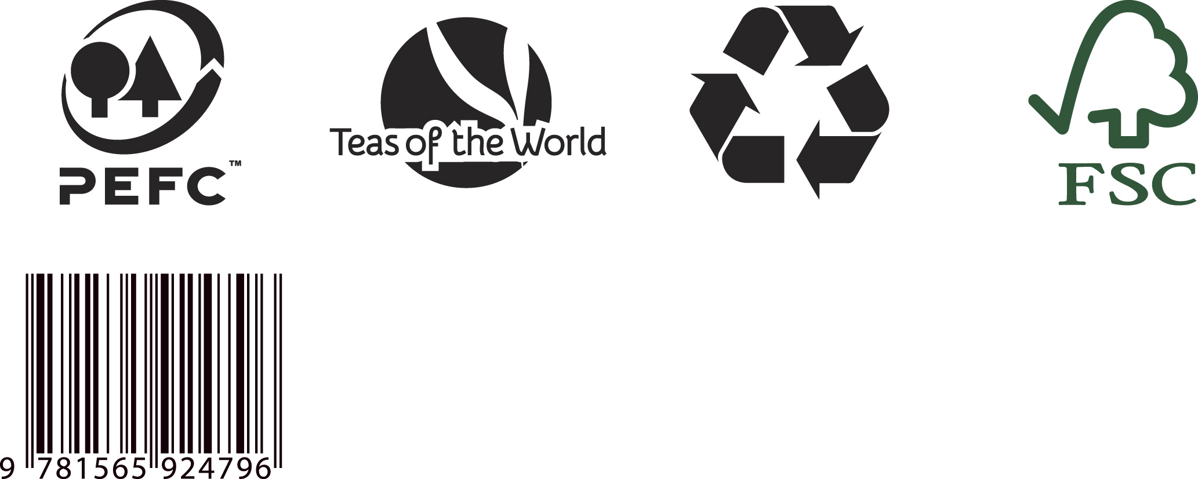
Appendix 2.3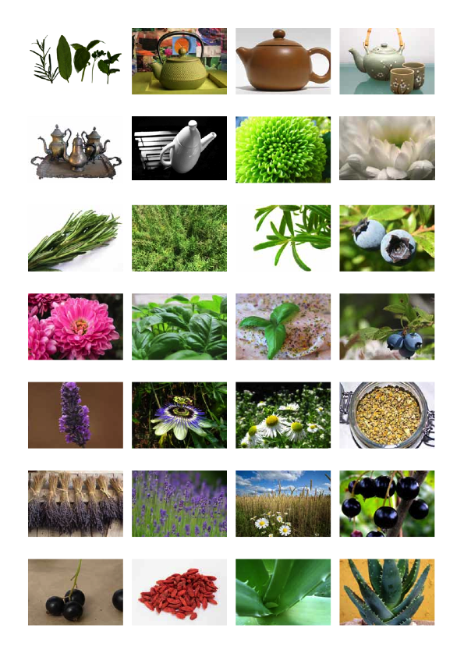

Appendix 2.3 (continued)

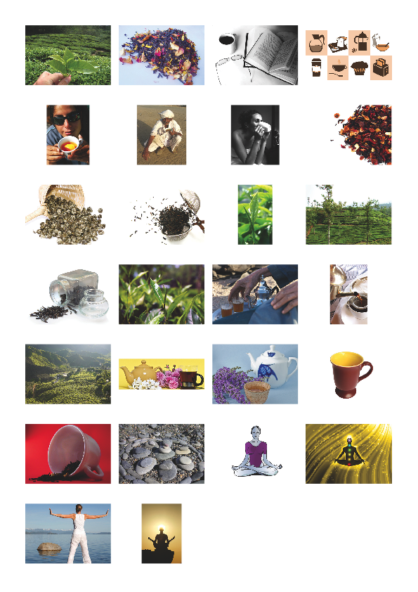

Appendix 3.1

Appendix_3.1.txt:

Label 1

Sensorial Tea Range: Teas to alter your body, mind and spirit

Meditation Tea
For calming and relaxing the body and mind
30g

Label 2

Sensorial Tea Range: Teas to alter your body, mind and spirit

Uplifting Tea
For happiness and energising the spirit
30g

Label 3

Sensorial Tea Range: Teas to alter your body, mind and spirit

Concentration Tea
For concentration and mental vigour
30g

